MAX30100 Pulse Oximeter Sensor with Arduino
Interfacing MAX30100 Pulse Oximeter Sensor with Arduino. The MAX30100 Sensor is capable of measuring Blood Oxygen & Heart Rate. We can use any display like a 16×2 LCD Display to view the value of SpO2 and BPM. The blood Oxygen Concentration termed SpO2 is measured in Percentage and Heart Beat/Pulse Rate is measured in BPM.
The MAX30100 is a Pulse Oximetry and heart rate monitor sensor solution. It combines two LEDs, a photodetector, optimized optics, and low-noise analog signal processing to detect pulse oximetry and heart-rate signals.

Components

Arduino UNO Board

MAX30100 Pulse Oximeter Sensor

16x2 LCD Display

Potentiometer 10K

Ardino Uno:

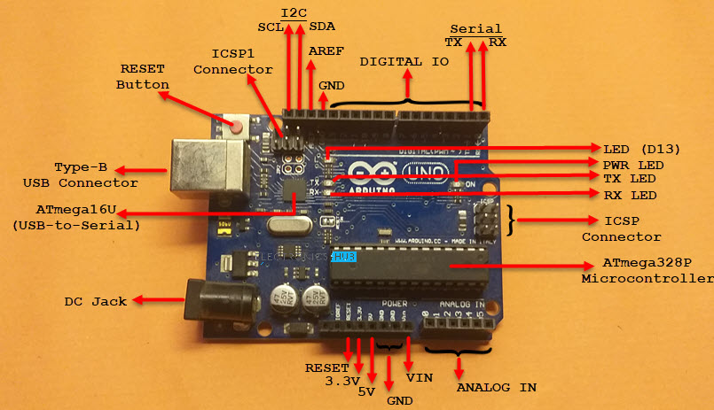

Arduino Uno is a microcontroller board based on the ATmega328P (datasheet). It has 14 digital input/output pins (of which 6 can be used as PWM outputs), 6 analog inputs, a 16 MHz ceramic resonator (CSTCE16M0V53-R0), a USB connection, a power jack, an ICSP header and a reset button. It contains everything needed to support the microcontroller; simply connect it to a computer with a USB cable or power it with a AC-to-DC adapter or battery to get started.. You can tinker with your Uno without worrying too much about doing something wrong, worst case scenario you can replace the chip for a few dollars and start over again.

MAX30100

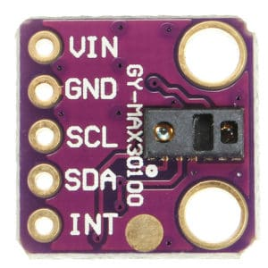

The device has two LEDs, one emitting red light, another emitting infrared light. For pulse rate, only infrared light is needed. Both red light and infrared light are used to measure oxygen levels in the blood.
When the heart pumps blood, there is an increase in oxygenated blood as a result of having more blood. As the heart relaxes, the volume of oxygenated blood also decreases. By knowing the time between the increase and decrease of oxygenated blood, the pulse rate is determined.
It turns out, oxygenated blood absorbs more infrared light and passes more red light while deoxygenated blood absorbs red light and passes more infrared light. This is the main function of the MAX30100: it reads the absorption levels for both light sources and stores them in a buffer that can be read via I2C communication protocol.

LCD 16x2:

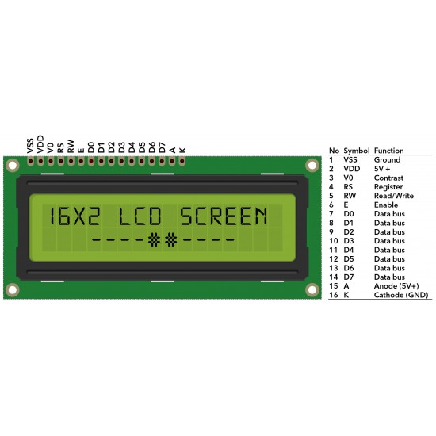

The term LCD stands for liquid crystal display. It is one kind of electronic display module used in an extensive range of applications like various circuits & devices like mobile phones, calculators, computers, TV sets, etc. These displays are mainly preferred for multi-segment light-emitting diodes and seven segments. The main benefits of using this module are inexpensive; simply programmable, animations, and there are no limitations for displaying custom characters, special and even animations, etc.

How does Pulse Oximeter Works?

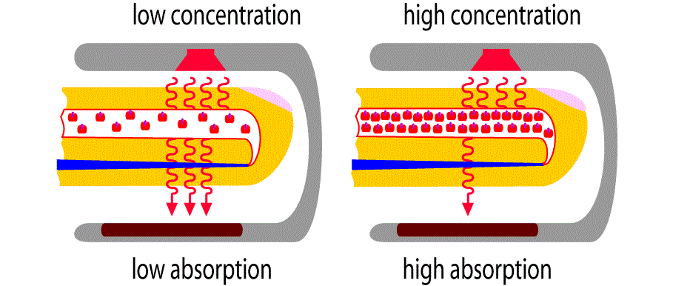

Oxygen enters the lungs and then is passed on into blood. The blood carries oxygen to the various organs in our body. The main way oxygen is carried in our blood is by means of hemoglobin. During a pulse oximetry reading, a small clamp-like device is placed on a finger, earlobe, or toe.

Small beams of light pass through the blood in the finger, measuring the amount of oxygen. It does this by measuring changes in light absorption in oxygenated or deoxygenated blood.

Circuit Diagrm:

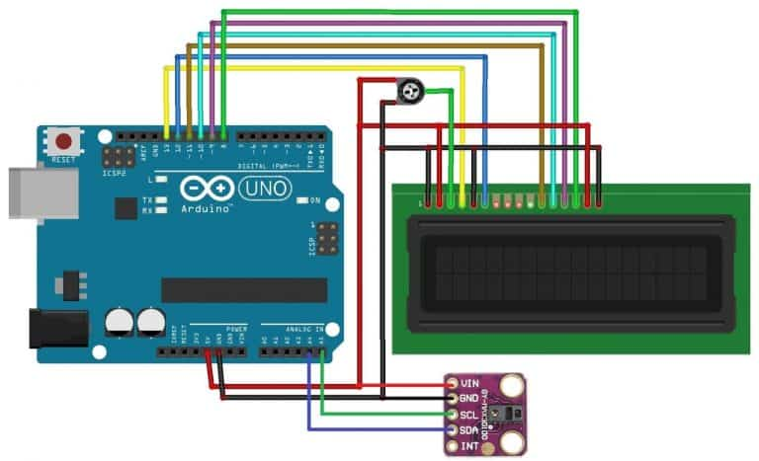

Program:

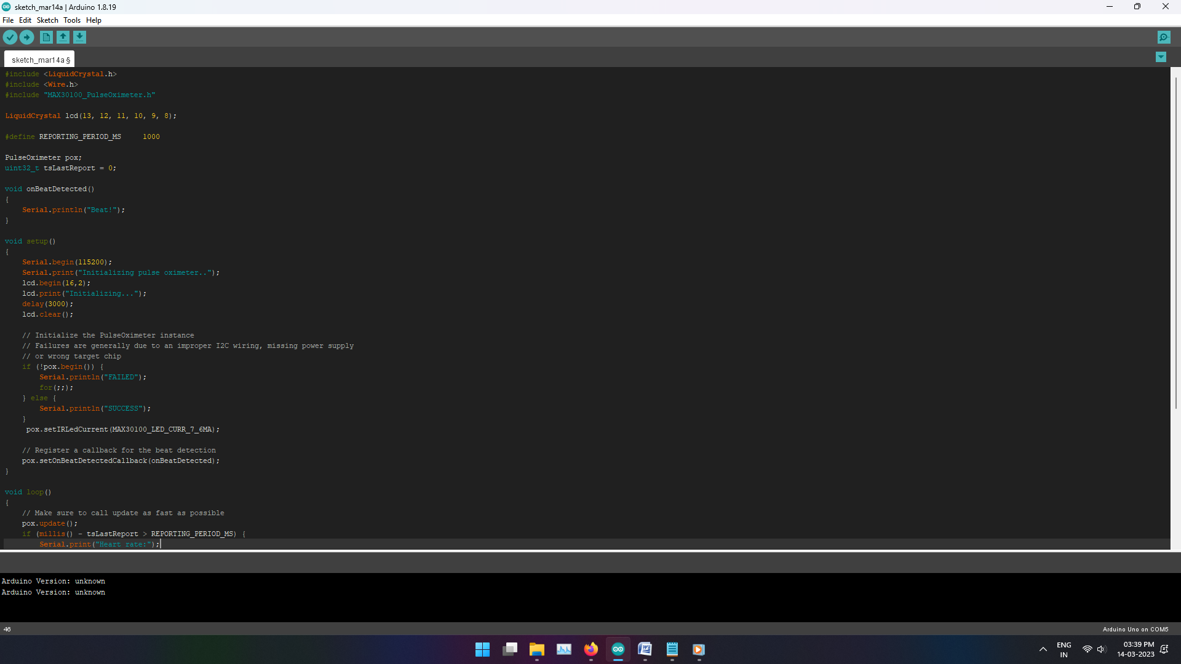

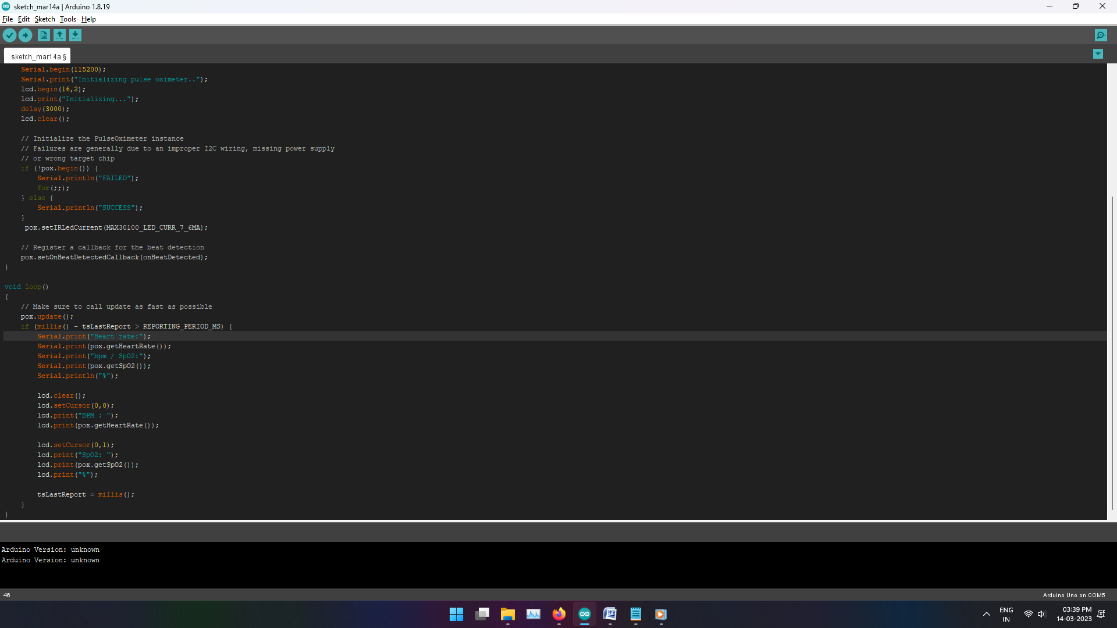

Output:

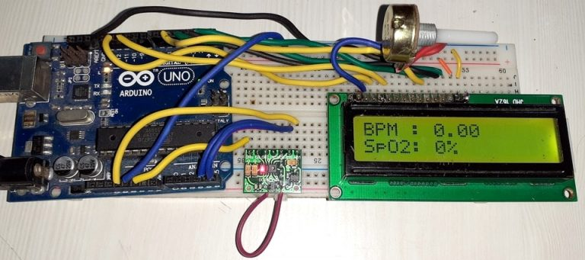

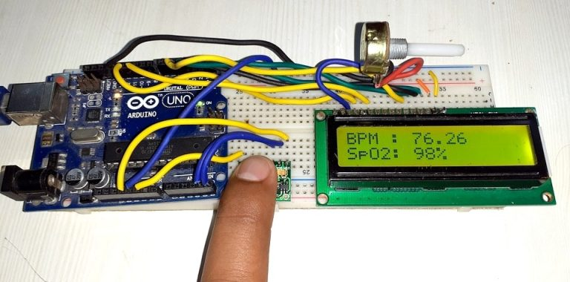

Conclusion:

Finally, we have completed Interfacing MAX30100 MAX30100 Pulse Oximeter Sensor with Arduino & LCD. Now, you can see the Heart beat and Oxygen level from the LCD Screen.

